What is VistAFlashTM?
VistAFlashTM is a copy of the OSEHRA Vagrant automated installer VistA instance. It is designed to be a copy consistent with the OSEHRA standard, while making it easier to update in the future. It uses a combination of portable technologies and custom scripts to make the process more seamless and easier for basic users.

Requirements

VistAFlashTM requires the following:
- USB Flash Drive of 16GiB or greater
  - Also, needs to formatted to ExFAT (to allow for greater than 4GiB files)
  - Tutorial for formatting a USB Flash Drive to ExFat: http://lifehacker.com/5927185/use-the-exfat-file-system-and-never-format-your-external-drive-again
- Windows 7 or greater (Tested on Windows 7 and Windows 10 x64)
- No VirtualBox installed on the Host computer

NOTE: VistAFlashTM will fail to start if VirtualBox is installed on the Host (Windows) computer. This is due to a conflict between the Portable VirtualBox that comes with the distribution and the version on the host computer.

Creating a VistAFlashTM

To create a VistAFlashTM unzip the file downloaded from the OSEHRA Technical Journal to the root of a flash drive (NOT in a directory called VistAFlashTM) then run the Recreate_EHR.lnk This will setup the stick correctly to have all of the correct scripts and the files in the correct place. This can take greater than 30 minutes and depends on the speed of the USB Flash Drive and the USB bus it is connected to.

Starting the VistA VM
The VM is easily started, all that is required is the user to click on the script titled Start_EHR.Bat. This script will start the VM and prompt with an administrative prompt. If you wish to proceed, click Yes. Once this is completed, you’ll see a command prompt which will run the process of starting the VM. No other interaction is required or advised until the Command prompt is presented.
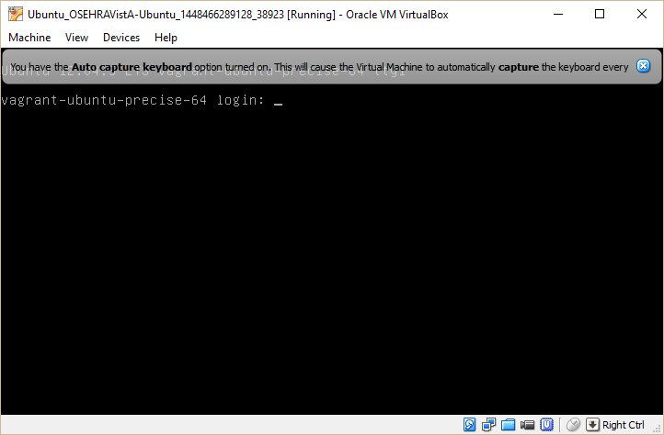
It is set to auto shutdown on successful completion.

Accessing VistA
To access VistA, there are two options detailed below: CPRS, and Roll and Scroll access. To start we provide the information to access CPRS.

CPRS and Other GUI Programs
CPRS is already preconfigured, though the note below shows how it functions with the RPC Broker. To Access, all you have to do is click on the CPRSChart shortcut. This will launch and the Access Code and Verify Code are prompted below. Make sure the VistA VM is running prior to attempting to access CPRSChart. If it fails to launch, see Recreating VistAFlashTM steps, below.
NOTE: CPRS uses the RPC Broker and the correct command-line arguments for VirtualBox are: S=127.0.0.1 P=9430.

VistA User Accounts

Doctor:
Access: fakedoc1
Verify: 1Doc!@#$
Electronic Signature: ROBA123

Nurse:
Access: fakenurse1
Verify: 1Nur!@#$
Electronic Signature: MARYS123

Clerk:
Access: fakeclerk1
Verify: 1Cle!@#$
Electronic Signature: CLERKJ123

Accessing Roll-and-Scroll
Click the PuTTY shortcut to open a PuTTY Configuration dialog to access Roll and Scroll
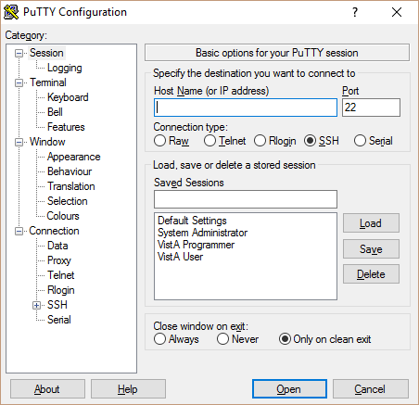
There are two user accounts that are created automatically during the installation process that make accessing VistA easier. These accounts are already setup for access in PuTTY. They are listed below, and have been identified with names set to identify their purpose.
When the PuTTY Configuration dialog pops up, select the desired user type from the Saved Sessions box in the right center of the dialog, then select Open. When the Command window opens, the User Name is already entered, you will need to enter the correct password, as noted below.
From there, you can use the VistA Access/Verify codes detailed above.

VistA User/Tied User Account
User Name: osehratied
Password: tied
The osehratied is designed for regular VistA users to access roll-and-scroll applications. This user is tied to the ^ZU routine.

VistA Programmer/Programmer User Account
User Name: osehraprog
Password: prog
The osehraprog is designed for programmer users to access the M prompt. This is the equivalent of typing mumps -dir at the command line.

Linux User (With sudo Privileges)
To login as a regular linux user (with sudo privileges), the following account is available in Putty as well.
User Name: vagrant
You can now use the system like any other linux box. If you need to access the VistA environment you can perform the following command:
vagrant@vagrant-ubuntu-precise-32:~$ mumps -dir
Which will give you a programmer prompt. To get to the normal VistA login screen type the following:
NOTE: the prompt OSEHRA> is based on the $instance variable as referenced above.
OSEHRA> D ^ZU

Shutdown VistAFlashTM VM
Shutting down the VM instance is as easy as starting it. You simply click on Shutdown_EHR.Bat, this will start the shutdown process. This will be the same as starting up, you see a command prompt, it will ask for administrative privileges, and finally it’ll close down both the VM and the command prompt. If the shutdown prompt ever stops in the middle, or gives the appearance of getting hung up, there is a command to halt this, it is Process_Kill.bat. This will kill all the processes associated with the EHR VM and shut the box down uncleanly, a rebuild is advised, but not always needed.

Recreating VistAFlashTM VM
To recreate, you’ll simply need to launch the file titled, Recreate_EHR.bat. This process will launch and unzip all of the files associated with the VM, then overwrite them with new files. This process is time consuming so only advised if side effects occur.

