

VFD*15.0*103
Release Notes

© 2016 Document Storage Systems, Inc. All rights reserved.

Document Storage Systems (DSS), Inc. is a privately held corporation and has been the premier provider of health information and document imaging distribution and storage systems to Veterans Affairs facilities for over eighteen years.
DSS is located at 12575 US Highway One, Suite 200, Juno Beach, Florida 33408.

World Wide Web: www.dssinc.com

vxVistA is a trademark of Document Storage Systems, Inc. Outlook, Internet Explorer, and Windows are trademarks of Microsoft Corporation. VistA is a trademark of the Department of Veterans Affairs, Software Services, and Computerized Patient Record System.

The patient data contained in this document has been generated on fictitious patients for demonstration and educational purposes. There is no actual Protected Health Information (PHI) contained in any “patient's” record.

December 2016

Table of Contents
Contents
Table of Contents ii
VFD*15.0*103 1
Pre-install Instructions 1
Install Instructions 1
Post-Install Instructions 1
Special Instructions 1
Detailed Functional Descriptions and History of Changes 2
T5 - Release Date [7/5/2016] 2
Functional Area: CPRS/Pharmacy 2
Internal Reference #: S35374 External Reference #: N/A 2
Category: Bug Fix Complexity: Medium 2
Description of Issue: 2
Resolution: 2
Known Issues: 2
QA Notes: 3
Components and Checksums: 4
Checksum Values of routines in this Build (Option: XTSUMBLD-CHECK/Routine: CHCKSUM^XTSUMBLD): 4
Unit Tests 4

OSEHRA JOURNAL SUBMISSION

VFD*15.0*103
[Licensed under Apache 2.0]

Pre-install Instructions
None.

Install Instructions
  - File Name: vfd_15_0_103_[T#].kid
  - Install Instructions: Use the normal KIDS Load and Install options to install this Build. (or any other specific installation instructions)
Code change to CPRS in file fODMeds.pas. (Code highlighted was added.) CPRS needs to be recompiled.
if ((valFor(VAL_SEQUENCE,r) = 'AND') or (valFor(VAL_SEQUENCE,r) = '')) and (AdminTime > -1) and (EndCheck = false) then
begin
//if (CompSch = '') and (LastSch <> '') and (Aschedule <> '') then CompSch := LastSch;
if (ASchedule <> '') and (CompSch <> '') and (RowCheck = False) then ASchedule := ASchedule + ';' + CompSch;
if (ASchedule = '') and (CompSch <> '') and (RowCheck = False) then ASchedule := ';' + CompSch;
end
else if (ValFor(VAL_SEQUENCE, r) = 'THEN') and (EndCheck = False) then
begin
// if (CompSch = '') and (LastSch <> '') and (Aschedule <> '') then CompSch := LastSch;
if (ASchedule <> '') and (CompSch <> '') and (RowCheck = False) then ASchedule := ASchedule + ';' + CompSch;
if (ASchedule = '') and (CompSch <> '') and (RowCheck = False) then ASchedule := ';' + CompSch;
EndCheck := True;
End

Post-Install Instructions
None.

Special Instructions
None.

Detailed Functional Descriptions and History of Changes
Sam Habiel
T10 – Release Date [12/21/2016] (Defect DE14096)
Another bug was found in the T8 work: stop dates were adjusted whether or not the next conjunction was a THEN. The code is now restricted to change the stop date only if the conjunction of the current order is THEN.
T9 – Release Date [12/19/2016]
A bug was found in the T8 work, where if the schedule sent was a Day of Week (DOW) Schedule, the looping variable in the HL7 subsystem in pharmacy (II) was overwritten by the DOW analyzer in the pharmacy package, causing an infinite loop that kept creating orders. This loop had the side effect of locking each new order created, resulting in filling of the lock table. This bug was fixed by newing II before calling STRT^ORCSEND1.
T8 – Release Date [12/2/2016]
A brand new bug was found in the same area; this time it’s the pharmacy package that is responsible for it. The stop dates for each portion of the complex order did not necessarily stop at the start of the next order. If that’s the case, there will be an overlap of coverage between the orders “thened” together. This may result in overdoses to patients.
T7 – Release Date [11/18/2016]
Unit tests fail at certain times of the day. This is now fixed, especially for days of week schedules; but perhaps not completely. All tests currently pass.
T6 – Release Date [11/17/2016]
Then uses the next day(s) even if the administration gap between two schedules is less than the then then time amount. This is how human interpret the “Then”. E.g., BID x 1d then QD x 1d should have the QD dose start the day after the BID dose, even if there are only 8 hours between the BID dose an the QD dose. This worked fine except for schedules less than daily, which is fixed in this build.

T5 - Release Date [7/5/2016]
Schedules that are less than once daily (BID or TID) may overlap days if a then is used between them, as a side effect of T1 version of this build. This is fixed.
T4 – Release Date [6/13/2016]
Second Schedule in an AND conjunction can precede the first one, as in Warfarin Day of Week Schedules
T3 - Release Date [6/9/2016]
Handling of QOD after a THEN conjunction
T2 - Release Date [6/8/2016]
Complete redesign of logic in ORCSEND1.

Functional Area: CPRS/Pharmacy

Internal Reference #: S35374 External Reference #: N/A

Category: Bug Fix Complexity: Medium

Description of Issue: Complex Orders with "THEN" conjunctions calculate when they are exploded out calculate the start date incorrectly for component orders. This was due to offsetting of the then duration from the start day of each order if it were by itself.
Resolution: The offsetting logic was enhanced to mirror user intention. See the comments in the routine ORCSEND1 for more details.
Known Issues: This build DOES NOT FIX the "Expected First Dose" help text on the order dialog. This is fixed by changing the CPRS source code as shown in the “Install Instructions” section.
QA Notes:
Test case: Patient is on titrating doses of Clozapine. The complex order was enter on 5/17/16@10:44
- Day 1: 12.5MG at 9:00
- Day 2: 25MG at 9:00
- Day 3: 50MG at 9:00 AND 12.5MG at 21:00
- Day 4 and after: 50MG at 9:00 AND 25MG at 21:00
- First issue: The Expected 1st dose should be tomorrow (5/18) @9:00, NOT today (5/17) @21:00

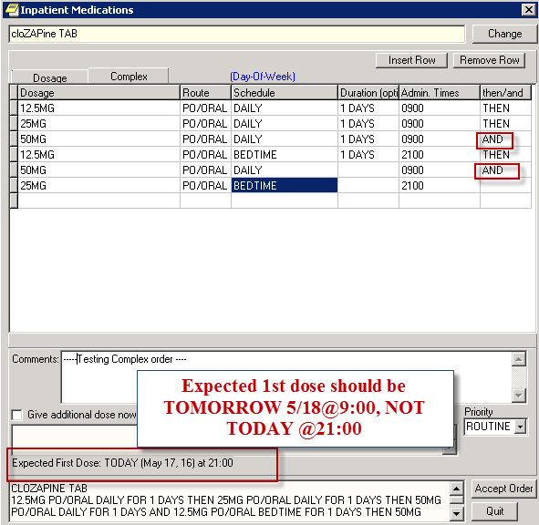
- Second issue: the START date for both bedtime doses is Incorrect

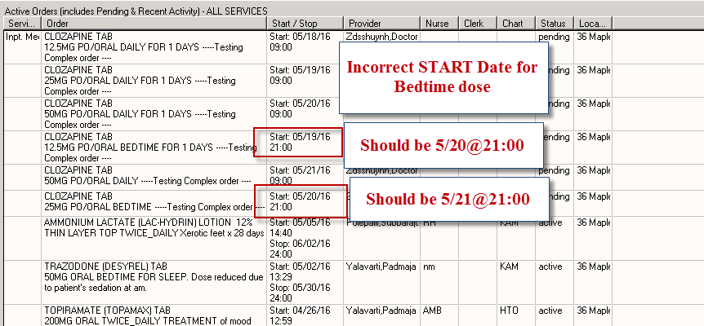

Components and Checksums:

Summary
PACKAGE: VFD*2013.1*104/VFD*15.0*103 Jun 08, 2016 11:49 am PAGE 1
-------------------------------------------------------------------------------
TYPE: SINGLE PACKAGE TRACK NATIONALLY: YES
NATIONAL PACKAGE: DSS,INC VXVISTA OPEN SOURCE ALPHA/BETA TESTING: NO

DESCRIPTION:
Rally Story S35374

ENVIRONMENT CHECK: DELETE ENV ROUTINE:
PRE-INIT ROUTINE: DELETE PRE-INIT ROUTINE:
POST-INIT ROUTINE: DELETE POST-INIT ROUTINE:
PRE-TRANSPORT RTN:

ROUTINE: ACTION:
ORCSEND1 SEND TO SITE
PSJORPOE SEND TO SITE
ZZTEST SEND TO SITE

Checksum Values of routines in this Build (Option: XTSUMBLD-CHECK/Routine: CHCKSUM^XTSUMBLD):
Routine | Old Checksum | New Checksum | Version# | Patch List
ORCSEND1 |  | 84011536 | 3.0 | **4,29,45,61,79,94,116,138,158,149,  187,215,243,282,323,394**
PSJORPOE |  | 39018236 | 5.0 | **50,56,92,80,110,127,133,134,113,277**
ZZTEST |  | 9914396 |  | **103**
* Old checksum value is the checksum prior to these updates. New checksum value is the checksum for this particular build.

Unit Tests
Unit Tests were written using the OSEHRA M-Unit framework (https://github.com/joelivey/M-Unit). The Unit Tests cover all reported cases where the code was behaving incorrectly before.
Here’s the result:
>D ^ZZTEST

T1 - QD X2D + QD & HS X1D + QD........---------------------------- [OK] 16ms
T2 - QHS X1D + QD....---------------------------------------------- [OK] 0ms
T3 - QD X 1D + BID X 1D + BID & QHS........------------------------ [OK] 0ms
T4 - QD X1D & QOD X1D + QHS X1D + QOD (Erika's)........----------- [OK] 15ms
T5 - M-W-F & TU-TH-SA ....---------------------------------

