OSEHRA JOURNAL SUBMISSION

VFD*15.0*103
[Licensed under Apache 2.0]

Pre-install Instructions
None.

Install Instructions
  - File Name: vfd_15_0_103_[T#].kid
  - Install Instructions: Use the normal KIDS Load and Install options to install this Build. (or any other specific installation instructions)
Code change to CPRS in file fODMeds.pas. (Code highlighted was added.) CPRS needs to be recompiled.
if ((valFor(VAL_SEQUENCE,r) = 'AND') or (valFor(VAL_SEQUENCE,r) = '')) and (AdminTime > -1) and (EndCheck = false) then
begin
//if (CompSch = '') and (LastSch <> '') and (Aschedule <> '') then CompSch := LastSch;
if (ASchedule <> '') and (CompSch <> '') and (RowCheck = False) then ASchedule := ASchedule + ';' + CompSch;
if (ASchedule = '') and (CompSch <> '') and (RowCheck = False) then ASchedule := ';' + CompSch;
end
else if (ValFor(VAL_SEQUENCE, r) = 'THEN') and (EndCheck = False) then
begin
// if (CompSch = '') and (LastSch <> '') and (Aschedule <> '') then CompSch := LastSch;
if (ASchedule <> '') and (CompSch <> '') and (RowCheck = False) then ASchedule := ASchedule + ';' + CompSch;
if (ASchedule = '') and (CompSch <> '') and (RowCheck = False) then ASchedule := ';' + CompSch;
EndCheck := True;
End

Post-Install Instructions
None.

Special Instructions
None.

Detailed Functional Descriptions and History of Changes

Release Date [7/5/2016]
Sam Habiel
Schedules that are less than once daily (BID or TID) may overlap days if a then is used between them, as a side effect of T1 version of this build. This is fixed.
Second Schedule in an AND conjunction can precede the first one, as in Warfarin Day of Week Schedules
Handling of QOD after a THEN conjunction
Complete redesign of logic in ORCSEND1.

Functional Area: CPRS/Pharmacy

Internal Reference #: S35374

External Reference #:

Category: Bug Fix

Complexity: Medium

Description of Issue:
Complex Orders with "THEN" conjunctions calculate when they are exploded out calculate the start date incorrectly for component orders. This was due to offsetting of the then duration from the start day of each order if it were by itself.

Resolution:
The offsetting logic was enhanced to mirror user intention. See the comments in the routine ORCSEND1 for more details.

Known Issues:
This build DOES NOT FIX the "Expected First Dose" help text on the order dialog. This is fixed by changing the CPRS source code as shown in the “Install Instructions” section.

QA Notes
Test case: Patient is on titrating doses of Clozapine. The complex order was enter on 5/17/16@10:44
- Day 1: 12.5MG at 9:00
- Day 2: 25MG at 9:00
- Day 3: 50MG at 9:00 AND 12.5MG at 21:00
- Day 4 and after: 50MG at 9:00 AND 25MG at 21:00
- First issue: The Expected 1st dose should be tomorrow (5/18) @9:00, NOT today (5/17) @21:00

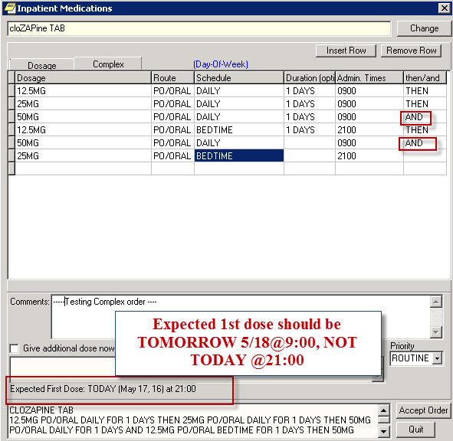
- Second issue: the START date for both bedtime doses is Incorrect

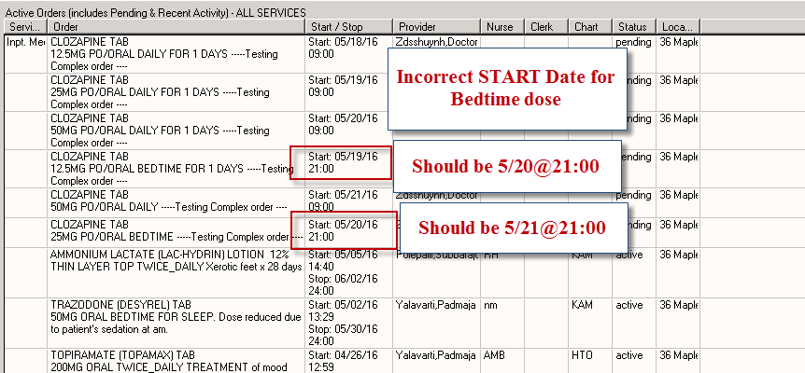

Components and Checksums

Summary
PACKAGE: VFD*2013.1*104/VFD*15.0*103 Jun 08, 2016 11:49 am PAGE 1
-------------------------------------------------------------------------------
TYPE: SINGLE PACKAGE TRACK NATIONALLY: YES
NATIONAL PACKAGE: DSS,INC VXVISTA OPEN SOURCE ALPHA/BETA TESTING: NO

DESCRIPTION:
Rally Story S35374

ENVIRONMENT CHECK: DELETE ENV ROUTINE:
PRE-INIT ROUTINE: DELETE PRE-INIT ROUTINE:
POST-INIT ROUTINE: DELETE POST-INIT ROUTINE:
PRE-TRANSPORT RTN:

ROUTINE: ACTION:
ORCSEND1 SEND TO SITE
PSJORPOE SEND TO SITE
ZZTEST SEND TO SITE

Checksum Values of routines in this Build (Option: XTSUMBLD-CHECK/Routine: CHCKSUM^XTSUMBLD):
Routine | Old Checksum | New Checksum | Version# | Patch List
ORCSEND1 |  | 84011536 | 3.0 | **4,29,45,61,79,94,116,138,158,149,  187,215,243,282,323,394**
PSJORPOE |  | 39018236 | 5.0 | **50,56,92,80,110,127,133,134,113,277**
ZZTEST |  | 9914396 |  | **103**
* Old checksum value is the checksum prior to these updates. New checksum value is the checksum for this particular build.

Unit Tests
Unit Tests were written using the OSEHRA M-Unit framework (https://github.com/joelivey/M-Unit). The Unit Tests cover all reported cases where the code was behaving incorrectly before.
Here’s the result:
>D ^ZZTEST

T1 - QD X2D + QD & HS X1D + QD........---------------------------- [OK] 16ms
T2 - QHS X1D + QD....---------------------------------------------- [OK] 0ms
T3 - QD X 1D + BID X 1D + BID & QHS........------------------------ [OK] 0ms
T4 - QD X1D & QOD X1D + QHS X1D + QOD (Erika's)........----------- [OK] 15ms
T5 - M-W-F & TU-TH-SA (Benson)....--------------------------------- [OK] 0ms

